INTRODUCTION TO WINDOWS FORM APPLICATION

ANSH ARORA

4 BCA B

FORM DESIGN

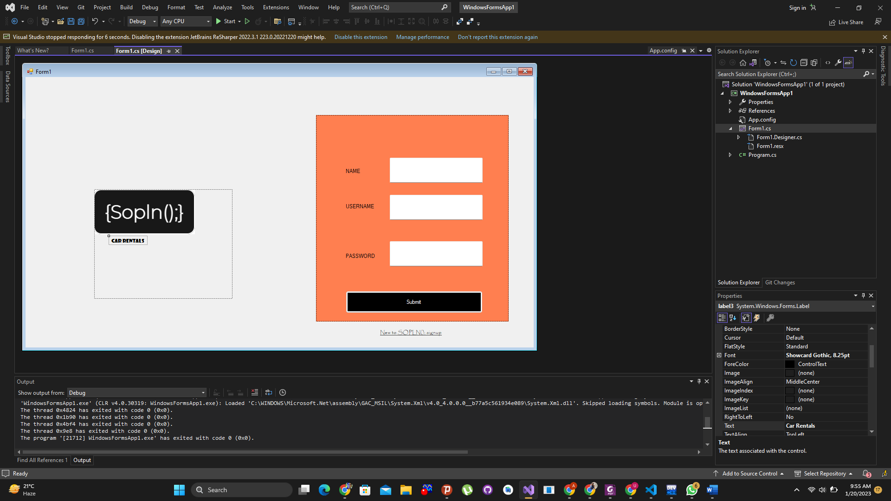

Components used

TextBox

PictureBox

Button

Label

Label Link

Output

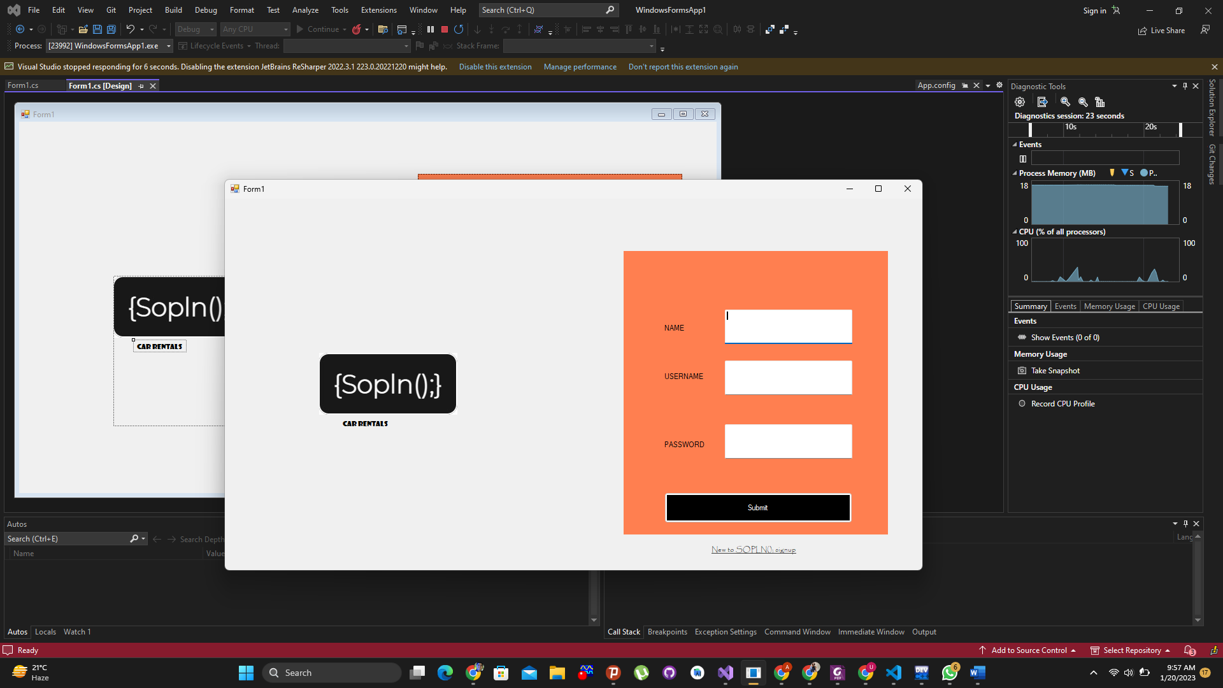

Thank you